WIREFRAMES DETAILED DROP DOWN LIST

* Fire Incidents and warnings

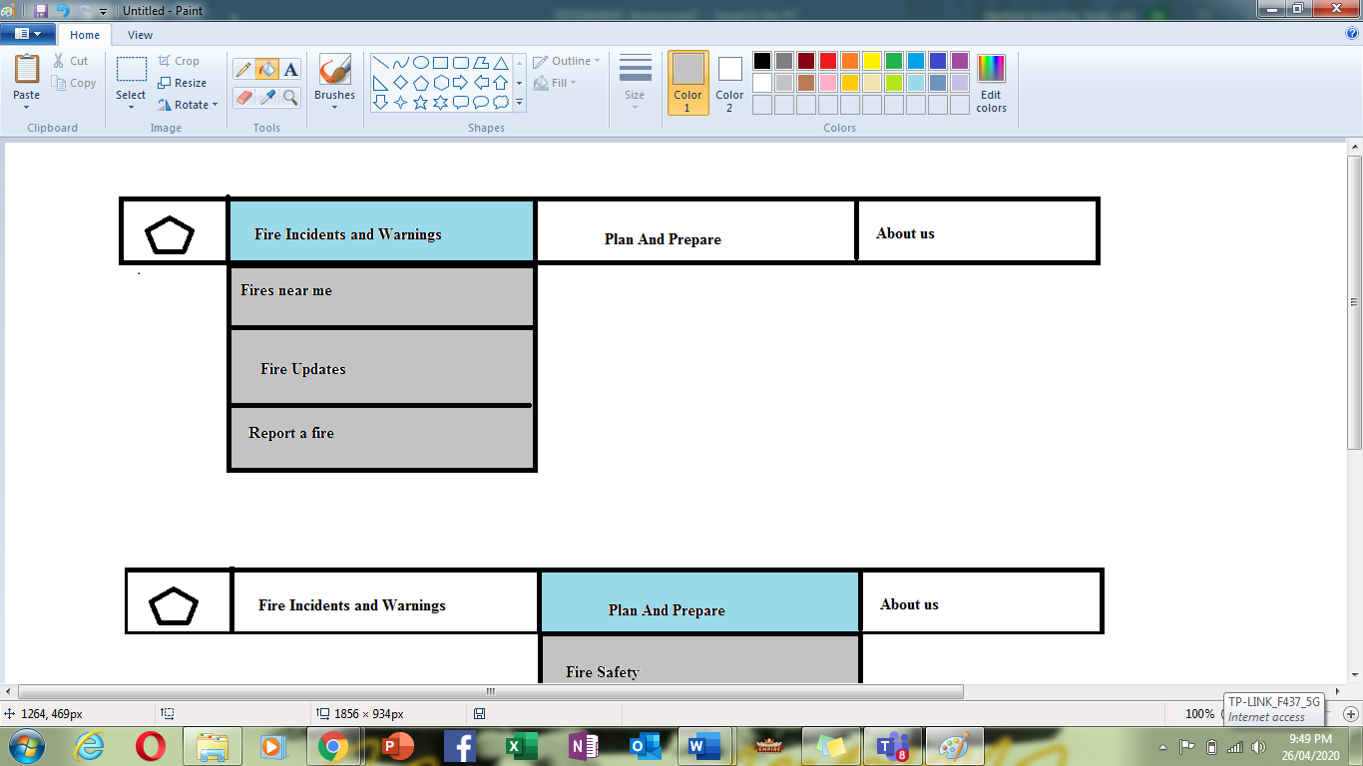

* Plan and Prepare

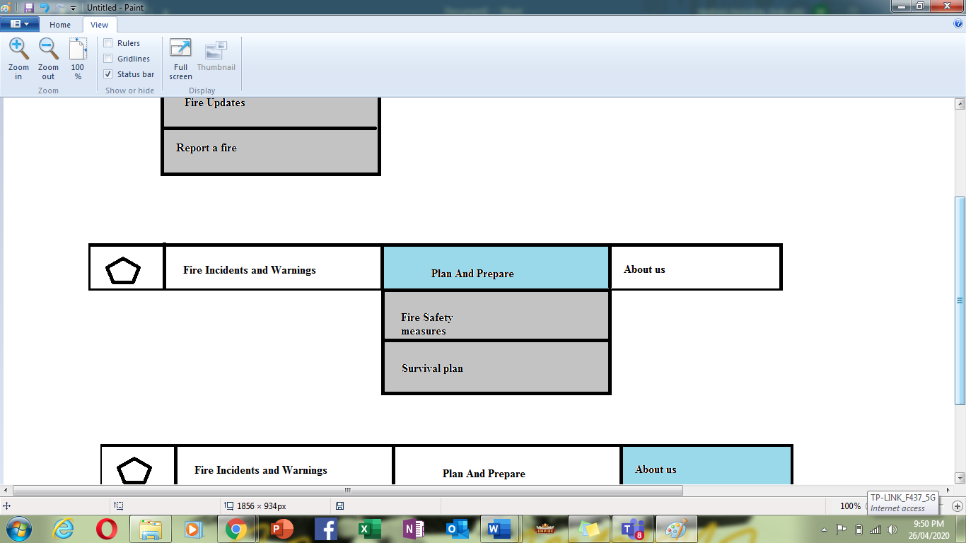

* About Us

